.Title

**Objective**

The objective of this laboratory exercise is to build an understanding of how to use the Code Composer Studio (CCS) Development System. The MSP432 microcontroller will be used to demonstrate how to create, compile, load, and debug programs. Such programs will show how to install and run firmware that interfaces to external I/O devices on the development board. This exercise will also explore a Graphical User Interface (GUI) between a PC and a MSP432 microcontroller on a development board.

**Introduction**

**Apparatus**

The apparatus used is listed below:

1. Code Composer Studio (CCS)
2. MSP432 Microcontroller on a development board
3. USB cable

**Procedure**

**Part I**

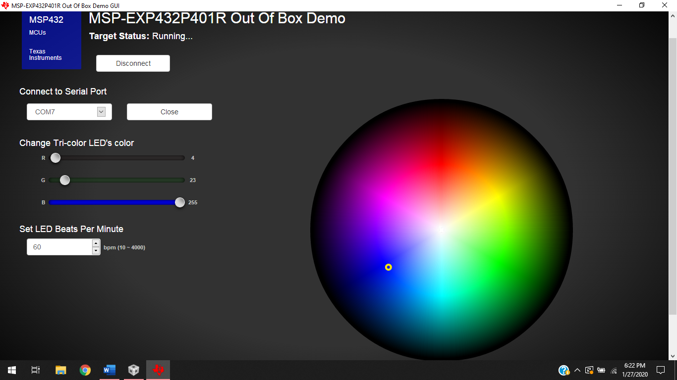

Figure 1: Out of the Box Graphical User Interface

**Part II**

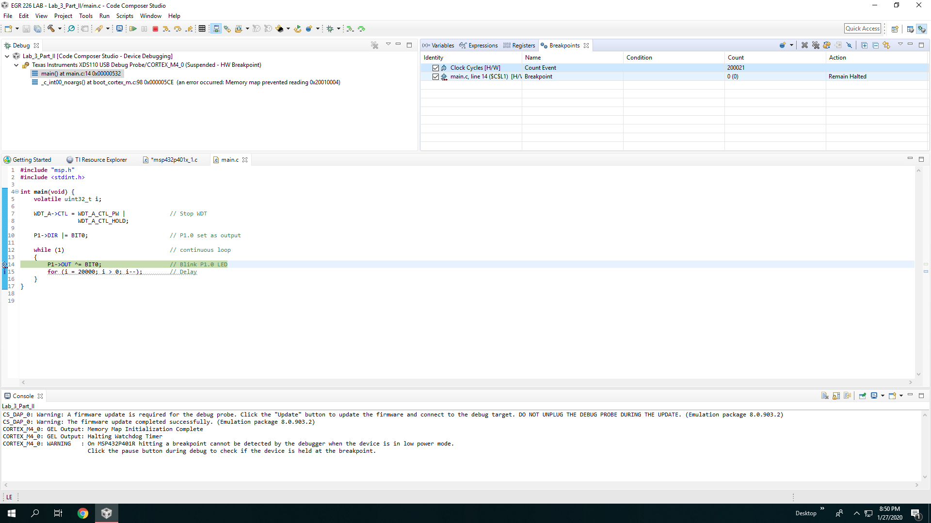

Figure 2: Display of counted 200021 cycles

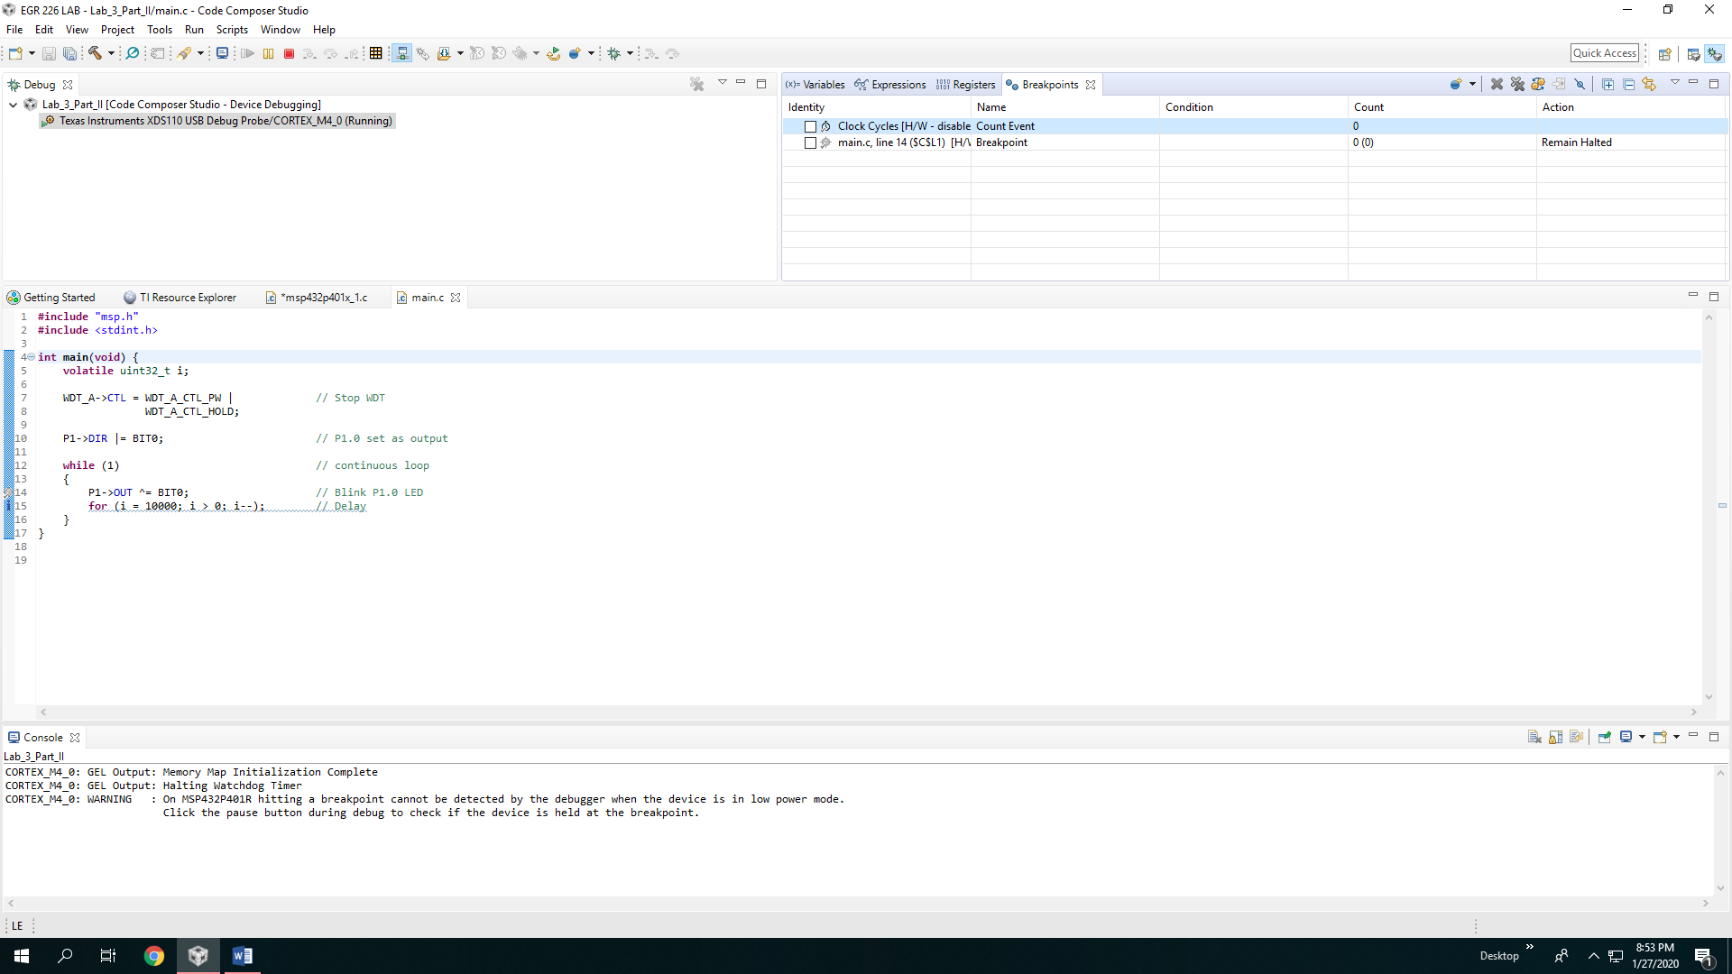

Figure 3: Display of counted 200021 cycles

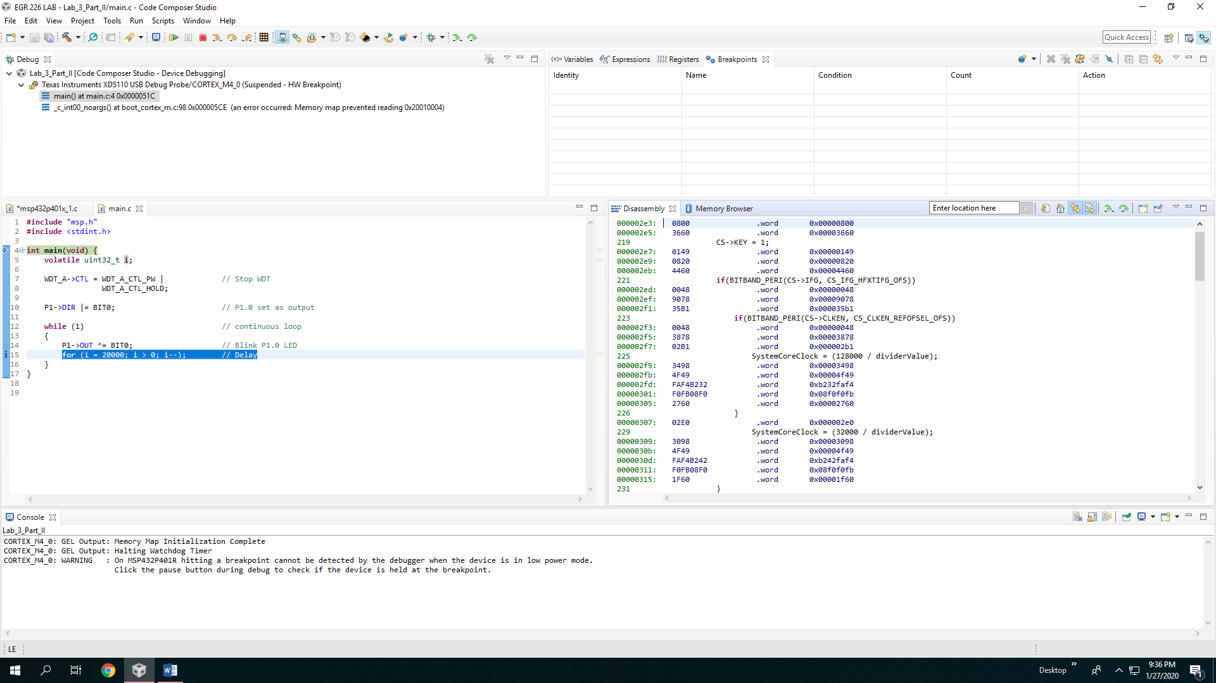

Figure 3: Disassembly of the Source Code

**Part III**

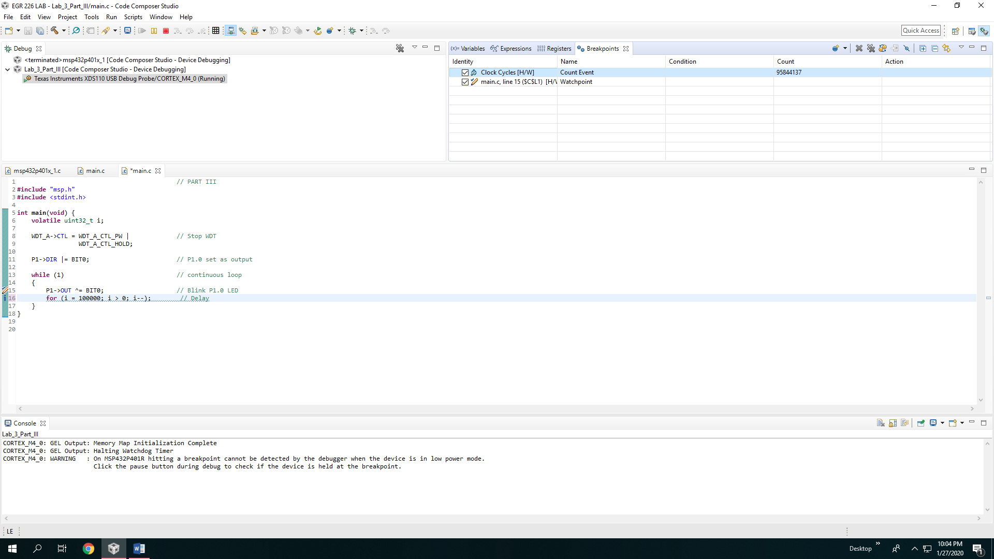

Figure #: Modified source code from part III, note the count is higher

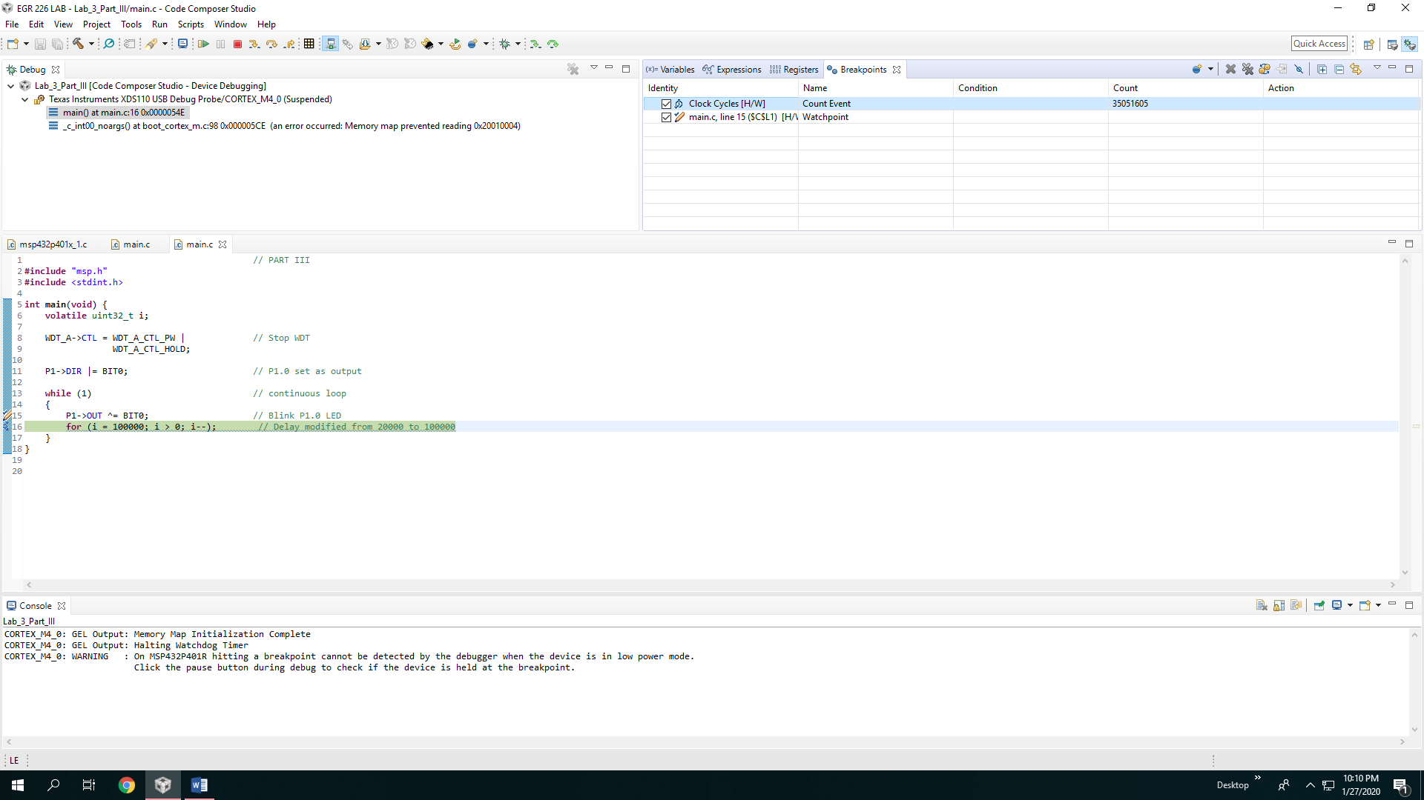

Figure #: Note the amount of count is higher

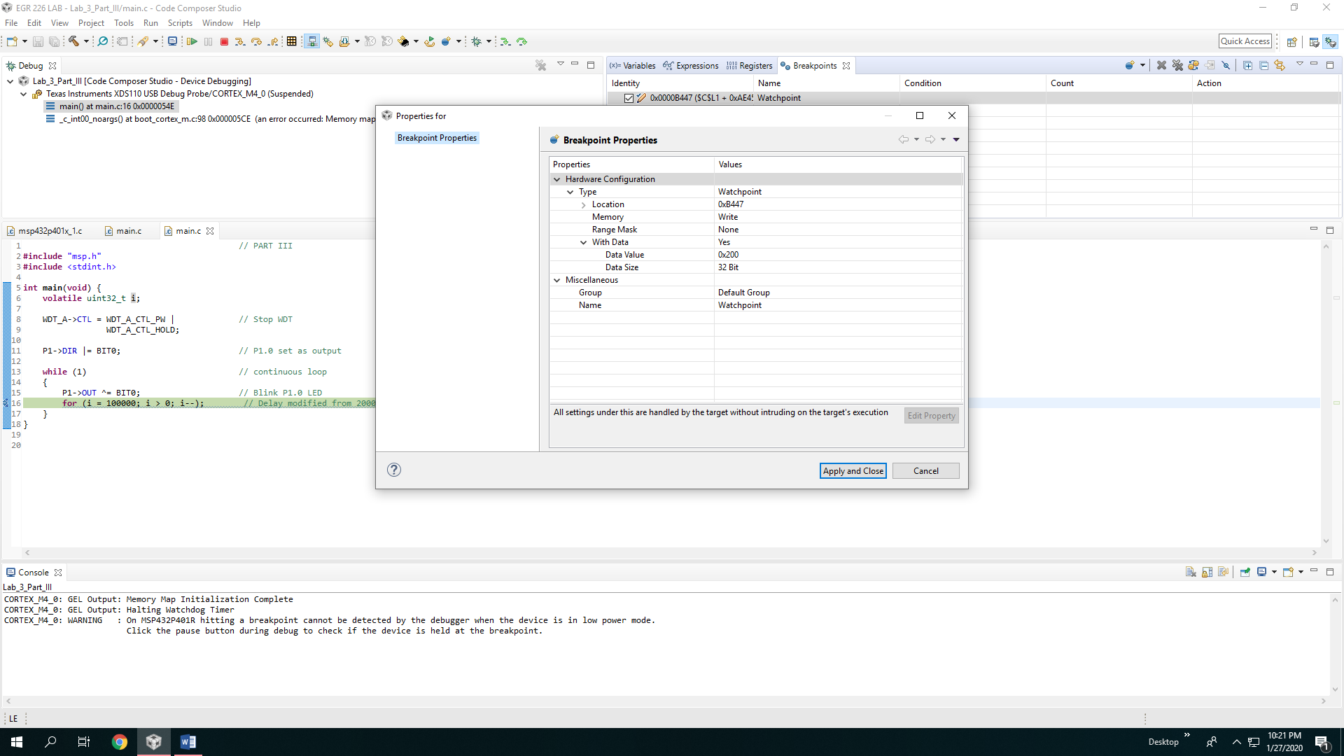

Figure #: shows a different data value for variable “I” at 0x200

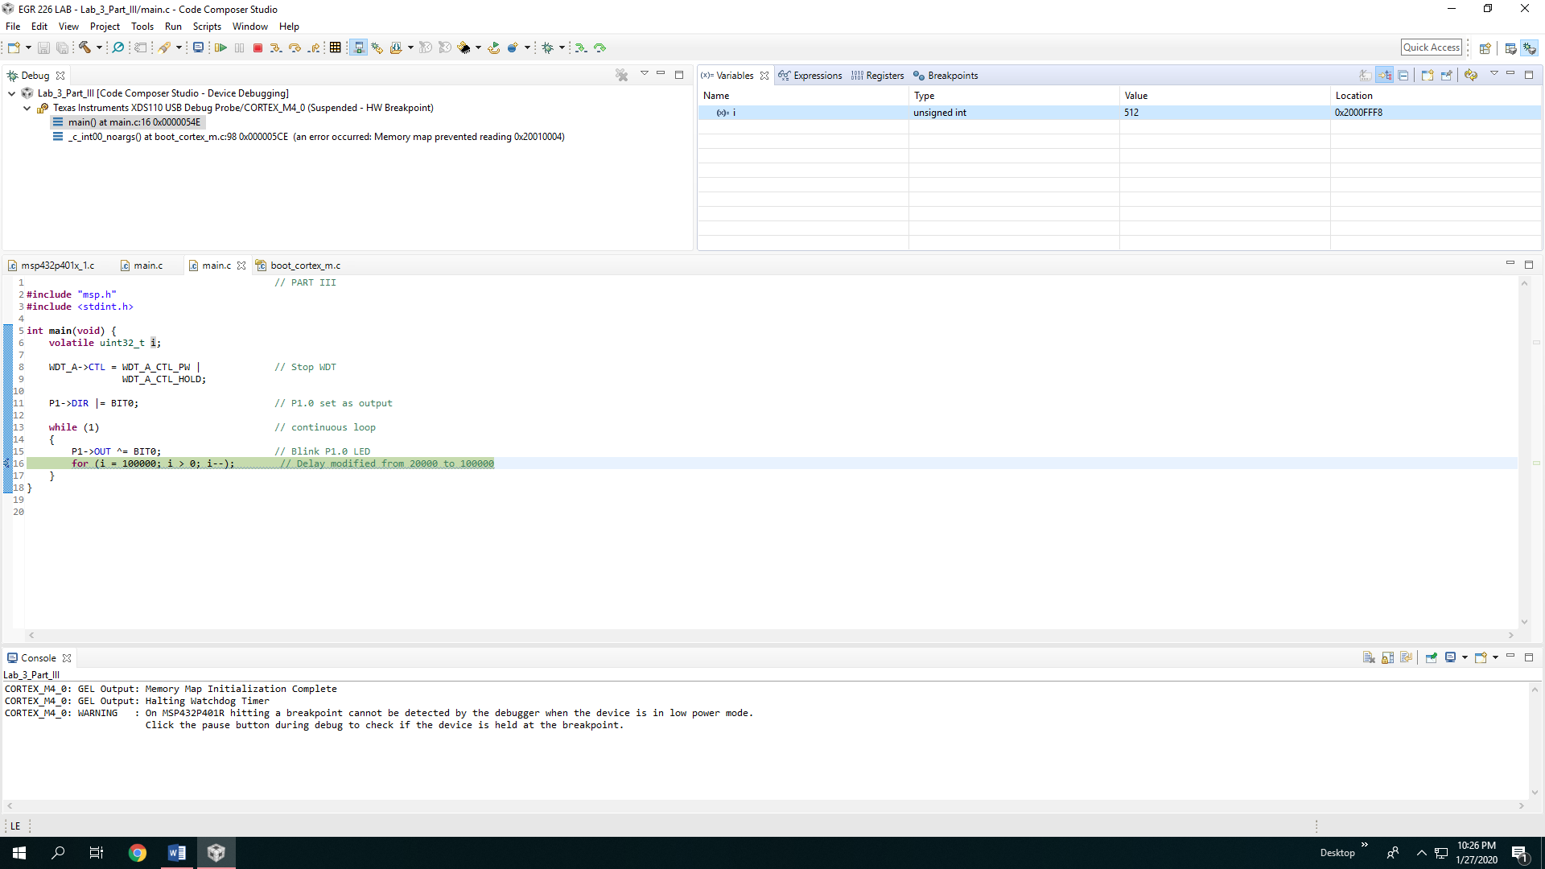

Figure #: Shows program suspended at 512 rather than 256

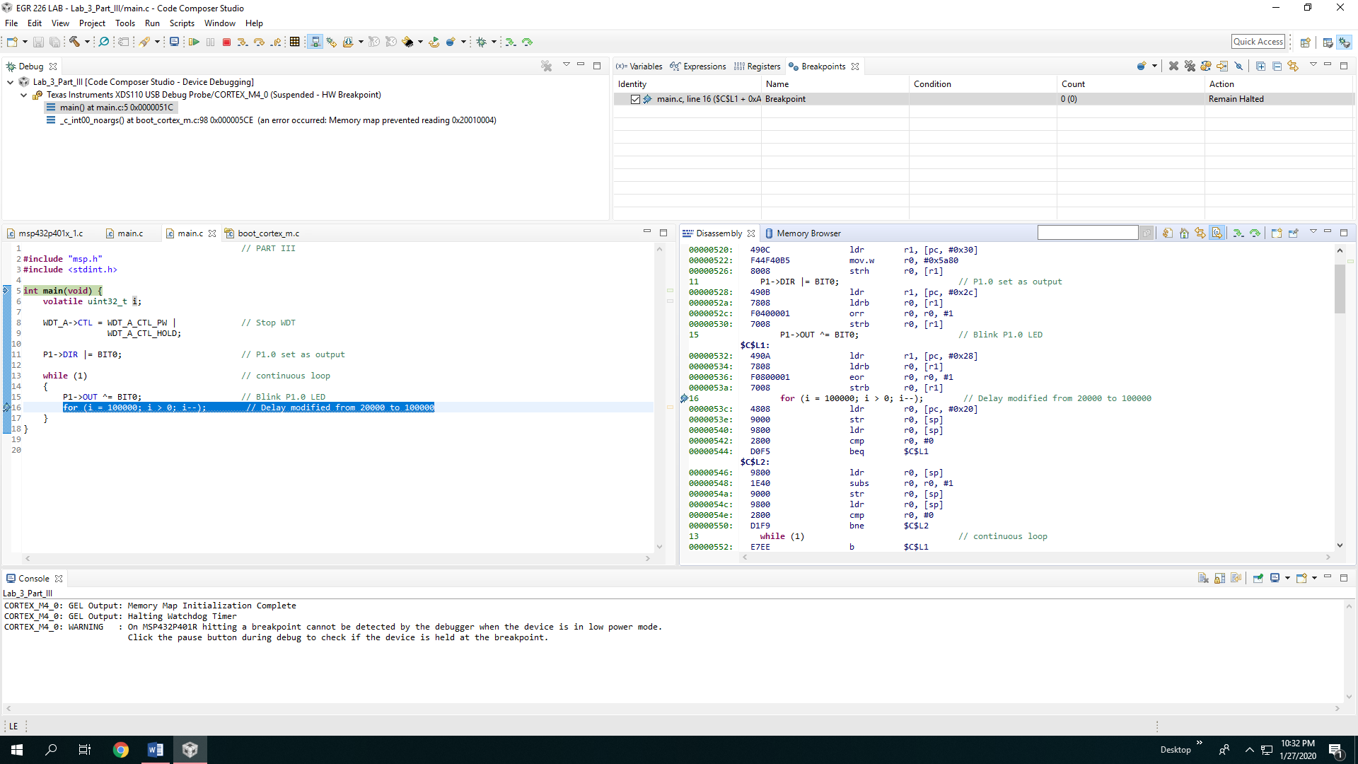

Figure #: Shows toggling and displays the disassembly

**Results**

**Conclusion**

**Appendix A**

Figure #: Code from Part II

**Appendix B**

Figure #: Code from Part III